Control phase in the DMAIC process
This marks the conclusion of the team’s journey. This is determined by the performance that has been established throughout the quality management process (Fırat, 2017). At this stage, different stakeholders are rewarded depending on the work done in the already completed project. At the end of the project, there is a need to leave a positive remark that can be used as a development plan for future projects.
What happens at the control phase?
This is the last stage in any project, one of the key thing that happens at this phase is the improvement and conclusion of the project. Any solution thought throughout the project is tested and implemented at this phase. Control phase is the fruit of the development process. The projects goals are also evaluated to ensure that no goal has been left out in the project. The control phase contains the control plan. The control plan is used to define the project characteristics and improvement that need to be done for the future project. This control plan is done through the use of dashboards, monitoring the mechanism that took place in the project as well as other alternative that can offer fixe solution to future projects. One the major tool used in the control plan is the Updating the FMEA. The FMEA tool helps the control phase to change processes in the cycle. Using the tool the potential risks are evaluated and possible solutions given that can curb the problem.

Training
Training is very essential in any project. Under the control phase the users are trained on how to adapt to the new system. They are taught about the different process and requirements needed in the project.

Companies using the control phase in their projects
Control phase has gained popularity over year. This has been brought about by the fact that projects needs a closing point and hence the introduction of the control phase. Such companies includes, Namaste Company in India, companies dealing with software solutions and many others are solution oriented.
Control roadmap
In hotel management setup, the control process was adopted to ensure that each step has been covered. The control phase acts as the checkpoint where all the phases are brought to board with the aim of cross-checking each step before presenting the final product to the hotel management staff (Berg, 2015).
Control chart
The charts shows how the activities in the control phase are conducted. The phase begins with risk mitigation, control plan and process monitoring.
The chart below shows part of the control phase that was used in the hotel setup.
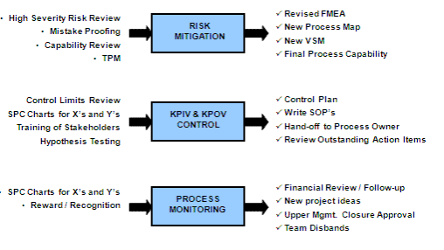
Source (Berg, 2015)
Each step in the phase is equally important because the hotel has to implement risk mitigation, approval and monitor the processes as well. There must be enough emphasis that needs to be done in each step. This makes it easy as the energy required for each step will be limited, and the management will have an easy time to implement the check in checkout system.
Under the control phase, the following ought to be done to ensure a successful conclusion of the project.
- Defining the processing capacity
- Closing the project successfully
- Communicating with the management as well as the celebration for a successful project.
Additionally, a cycle has been established to show the activities that takes place in the control phase which have not been mentioned in the later chart.
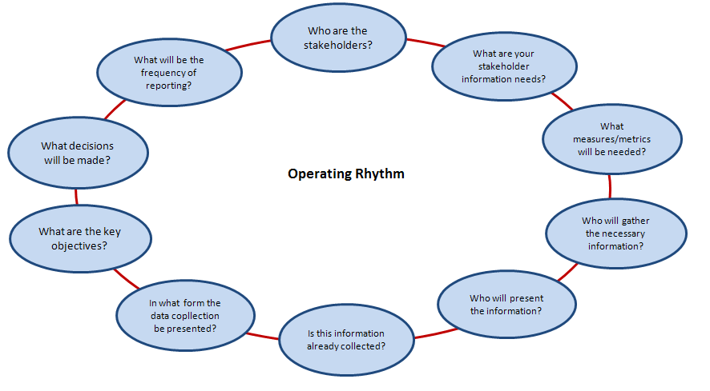
Source (Fırat, 2017)

Reference list
Fırat, S. Ü. O., Akan, M. Ö. A., Ersoy, E., Gök, S., & Ünal, U. (2017). A Six Sigma DMAIC Process for Supplier Performance Evaluation using AHP and Kano's Model. International Journal of Business Analytics (IJBAN), 4(2), 37-61.
Berg, S. A. (2015). Utilizing Six Sigma DMAIC Tools and Processes to Identify and Reduce Delamination and Scratch Defects on Privacy Filters (Doctoral dissertation, University of Wisconsin--Stout).

